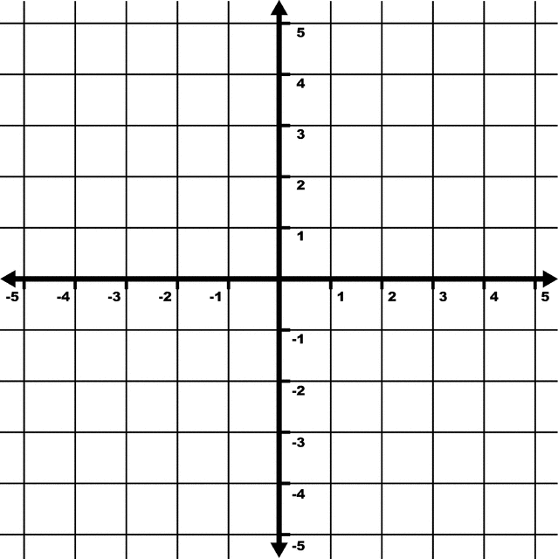
- Find the coordinates for the image with the given vertices A(-2,-1), B(0,2), C(0,0), D(1,-1) after the translation (x, y) → (x - 3, y +2). Draw the images.
- Reflect the figure with the given vertices across the given line, y = x. A(-5,2), B(4,1), C(-1,-2)

Draw the result of the composition of Transformations.
- a. ∆KLM has vertices K(-2,1 ), L(2,-1 ), and M(-1,-3 ). Rotate ∆KLM 270ᵒ Counter Clockwise about the origin and then reflect it across the x-axis.

b. Write a generic coordinate for the above transformations

- □PQRS has vertices P(1,1), Q(3,1 ), R(4,-1 ), and S(2,-2). Rotate □PQRS 180ᵒ about the origin and then translate it right 5 units and down 3 units.

b. Write a generic coordinate for the above transformations.

- ∆STR has verticies (0,-1), (2, 3), (-3, 4). On graph a) Reflect the figure over line y = 2. On graph b) reflect the figure over x = 1.
- b)

- ∆JKL has vertices (2, 4), (3, -1), (-2, 2). Rotate the figure 270CCW around the center point (1,2).

- What rotations about its center would a regular pentagon map onto itself from 0 to 360 degrees?

- Identify or draw three regular polygons that would map onto themselves if rotated 240º.

- How many lines of symmetry does a decagon have? How many does a parallelogram have?

- Draw the lines of symmetry for the following figure

