Identify the preimage, image, and dilation type of the following figures.
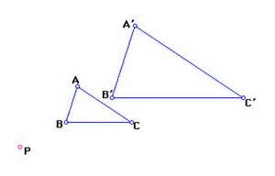
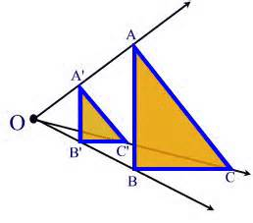
- 2.

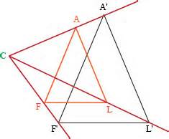

- Given that triangle ABC was dilated to triangle A’B’C’ and that AB is 14, BC is 21, and A’B’ is 6 find the scale factor of the dilation

- Given that triangle DEF was dilated to triangle D’E’F’ and that FD 11 is , DE is 15, and D’E’ is 60 find the scale factor.

- Identify the following from the given figure.
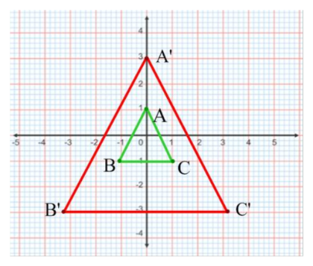
Image: _________________
Preimage:_______________
Dilation type: _______________
Scale Factor: ________________

- Identify the following from the given figure.
Image: _________________
Preimage:_______________
Dilation type: _______________
Scale Factor: ________________

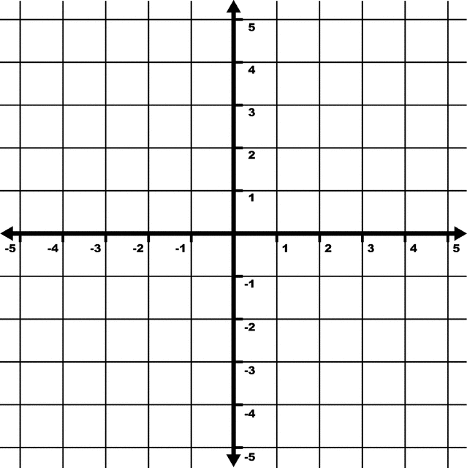
- Graph the following dilation. Center at (2,1). Points at A(1,3) B(-1, 2) C(0, -2) Scale factor 2.

- Graph the following. A Dilation with a Scale factor ¼, a center at (0,-2) and preimage points at A(12, 2), B(8, 6), C(12, 10), D(4,2).

