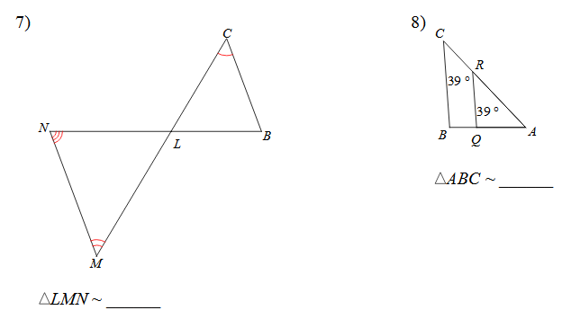
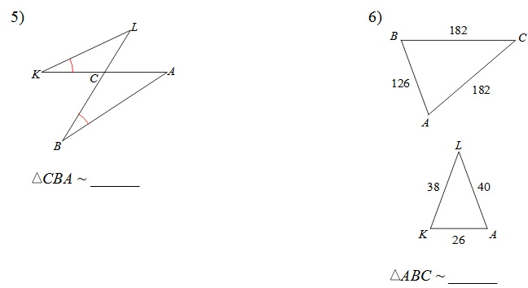
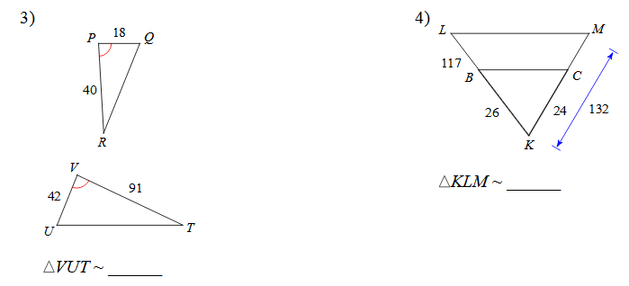
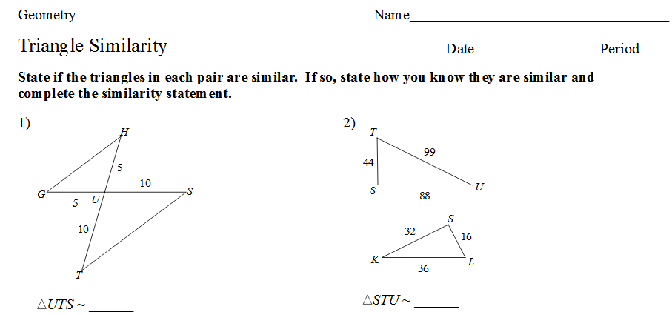
Triangle Similarity Remediation
Using the given figure to answer the following questions
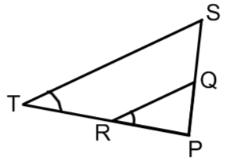
- Decide if ∆SPT and ∆QPR are similar. State the postulate or theorem that you could use to show that.

- If PT is 20, PR is 8, and PQ is 11, what is the length of PS?

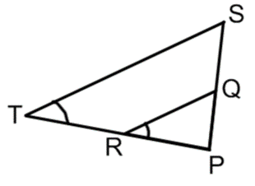
- What is the length QR if ST is 14, PR is 5 and RT is 9.

Using the given figure to answer the following questions
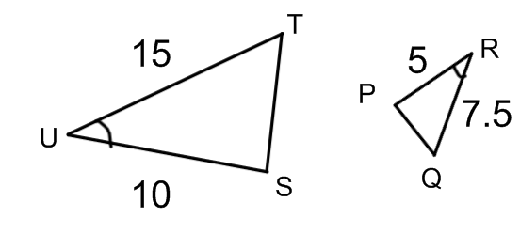
- Decide if ∆SUT and ∆PRQ are similar. State the postulate or theorem that you could use to show that.

- What is the length of ST if PQ = 4.

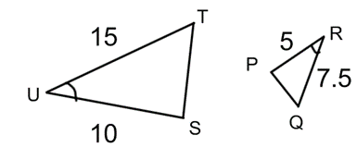

- What is the length of PQ if ST = 6.

Using the given figure to answer the following questions.
- Decide if the following triangles are similar. State the postulate or theorem that you could use to show that.
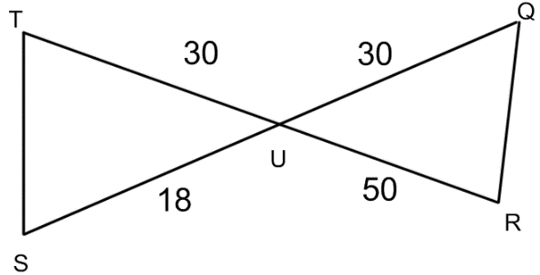

- What is the length of QR if ST = 15.

