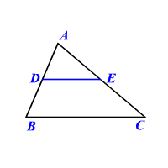
Use the following image for problems 7-12. Assume that DE is parallel to BC.
- Using the triangle proportionality theorem, find the value of x, if AD is 6, AE is 3x, DB is 12, and EC is 16.

- Using the triangle proportionality theorem, find the value of x, if AB is 18, AE is x-5, AD is 6, and EC is 20.

- Using the triangle proportionality theorem, find the value of x, if AC is 32, AD is x+2, DB is 9, and EC is 18.

Given that DE is a midsegment in the below triangles, find the value of x with the following information.
- DE = 12, and BC = x+4 5. BC = 84, DB = 14, and DE = 2x – 21

6. DE is x + 9 and BC is 4x+14.

